**Lesson 01 Demo 01**

**Creating Simple React Custom hook**

**Objective:** To demonstrate the basic operations click operation with custom react hook.

**Tools required:** Node JS and React JS

**Prerequisites:** HTML, CSS, JavaScript ES5/ES6, Basic React Concept

**Note** : All react js project already created with version 18.x with Sample App.js file

**Steps to be followed:**

1. Set up for react js project
2. Creating custom hook in separate external file.
3. Use custom hook in user defined components
4. Importing user defined functional component in App.js entry file
5. Step to run the application and check the output on browser.

**Step 1: Set up for react js project**

1. Open a terminal window inside a React JS pre-created project ie **simple-custom-hook**

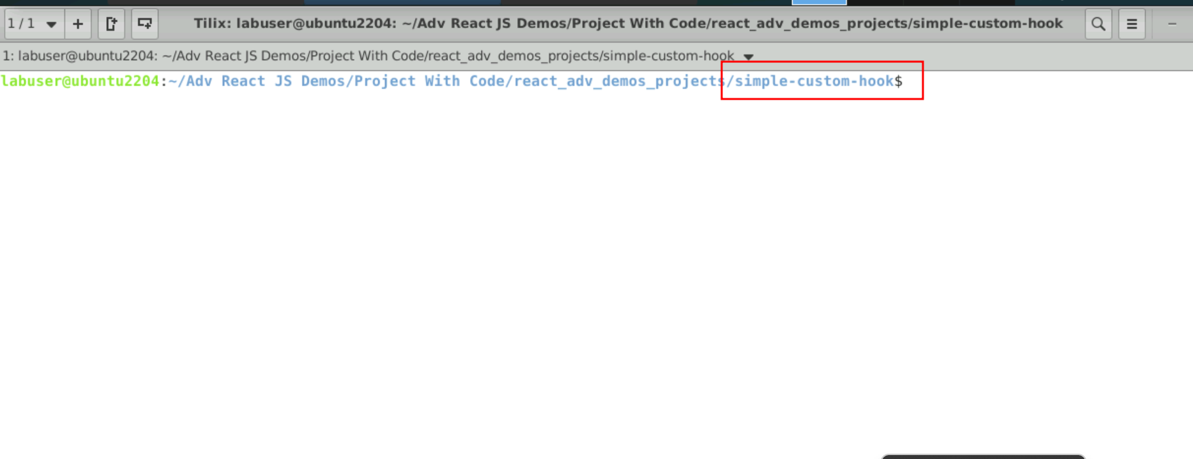

1. Now you need to run the command as **npm install.** This command help us to installed all required dependencies mention in package.json file in local machine in the form of node_module folder.

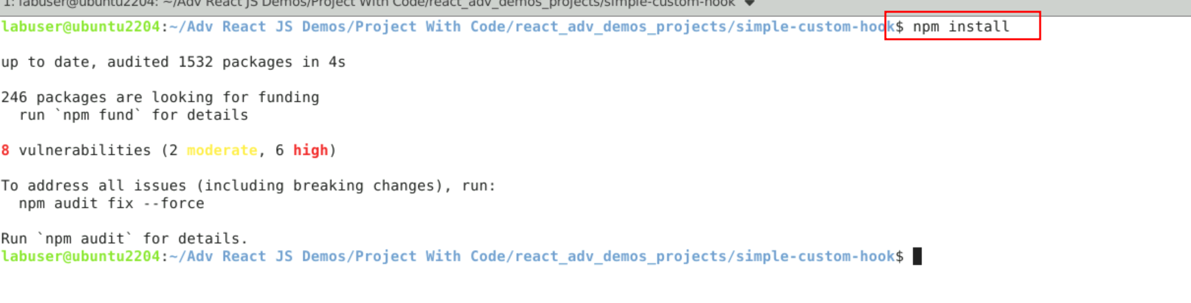

1. Now open **simple-custom-hook** folder in VS Code Editor

Note: short cut to open write **code .**

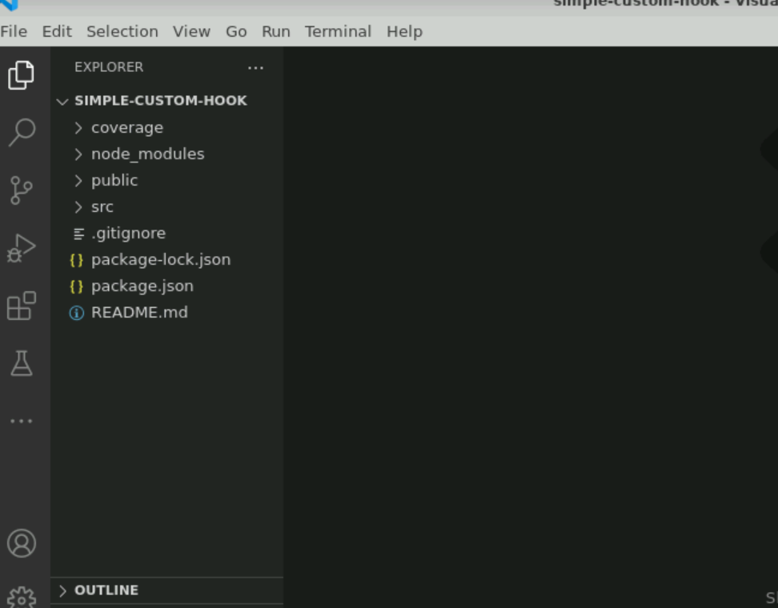

**Step 2: Creating custom hook in separate external file**

1. Now inside src folder create a **userCouter.js** file. Inside this file we are writing the logic to create the custom hook. The below Sample code take the help of useState as well as useEffect pre-defined hook function and creating custom hook. Which is responsible to provide increment the count variable value based upon event we can use in our user defined components.

2.2. Below code you need to write inside **userCouter.js** file

**userCouter.js**

import { useState,useEffect} from 'react';

function useCounter(intialCount = 0){

const [count, setCount] = useState(intialCount);

// Similar to componentDidMount and componentDidUpdate:

useEffect(() => {

// Update the document title using the browser API

document.title = `You clicked ${count} times`;

});

return [count, setCount];

}

export default useCounter;

**Step 3: Use custom hook in user defined components**

3.1 Now we need to create user defined component. So create CouterExample.js file inside src folder and import custom hook code inside CouterExample.js file and user custom hook functionality. Inside this component we are using custom component which help to increment the value when we click on button.

3.2 Below code you need to write inside a **CouterExample.js** file

import useCounter from "./userCounter";

function CouterExample() {

// Call custom hook `useCounter` to reuse Counter logic

const [count, setCount] = useCounter(0);

return (

<div>

<p>You clicked {count} times</p>

<button onClick={() => setCount(count + 1)}>

Click me

</button>

</div>

);

}

export default CouterExample;

**Step 4: Importing user defined functional component in App.js entry file**

4.1 Now inside App.js file we need to import our user defined component ie CounterExample

**App.js file**

import './App.css';

import CouterExample from './CouterExample';

function App() {

return (

<div>

<h2>Simple React Custom Hook Example </h2>

**<CouterExample></CouterExample>**

</div>

);

}

export default App;

4.2 After all files created in project your project looks files below

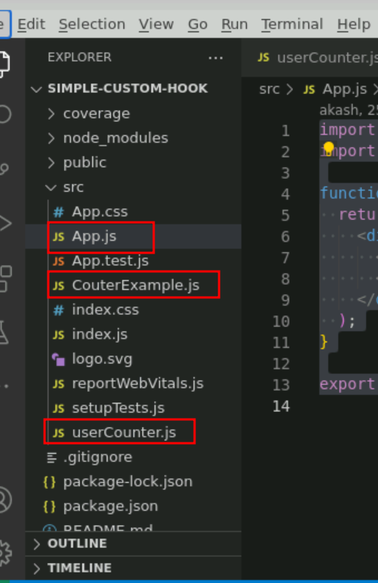

**Step 5 : Step to run the application and check the output on browser**

5.1 Now terminal window run the command as **npm start (**Make sure terminal open inside a project).

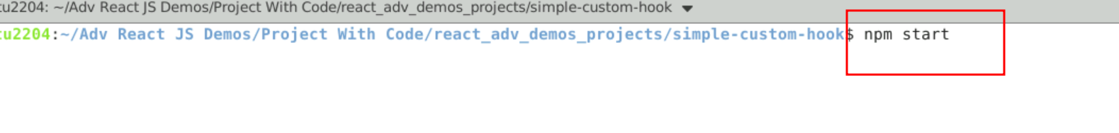

5.2 Now you project run on default browser with url as [**http://localhost:3000**](http://localhost:3000)

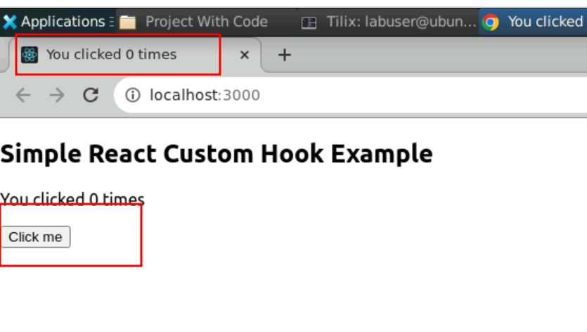

5.3 Now you can click on button to see the value increment.

